Assignment – 2
Hive Practice

Part A: Table Creation and Data Loading
- Create a managed table named airports with appropriate columns and data types based on the dataset provided.
- Create a managed table named airlines with the correct schema and data types.
- Create a managed table named routes using the dataset structure provided.
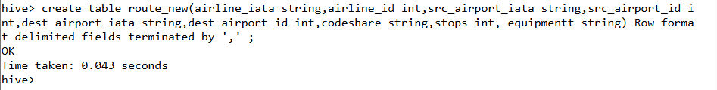
- Load data from local files (airports.txt, airlines.txt, routes.txt) into their respective tables.
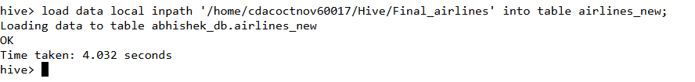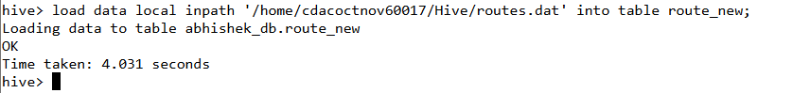
- Create an external table for airports that references data stored in a specific HDFS directory. Explain the difference in behavior when dropping the internal vs. external table.

Dropping a MANAGED (Internal) Table

Command: DROP TABLE airlines;

What happens: When you drop a managed table, Hive deletes both the table's metadata (schema) AND all of its data from the HDFS warehouse directory.

Result: The data is permanently gone. Hive assumes it "owns" the data and has the right to delete it.

Dropping an EXTERNAL Table

Command: DROP TABLE airports_external;

What happens: When you drop an external table, Hive deletes only the table's metadata (schema).

Result: The actual data files in the HDFS directory (/user/data/airports_data/) are NOT touched. The data is safe. This allows multiple tools (like Hive, Spark, etc.) to access the same data without fear of one tool deleting it.
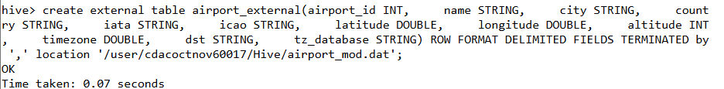

Part B: Joins and Querying
- Display all distinct countries that have at least one active airline operating.
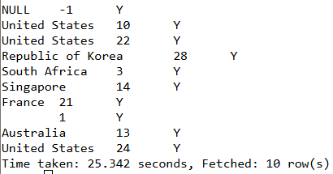

- List all airports along with their corresponding airline names by performing an appropriate join.
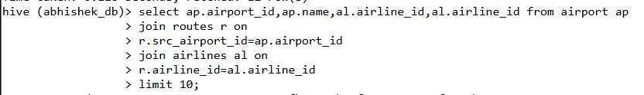
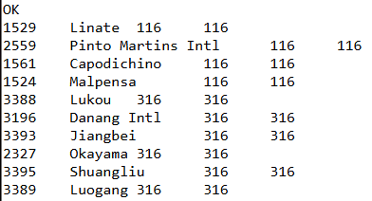

- Find all routes that operate between airports located in the same country.
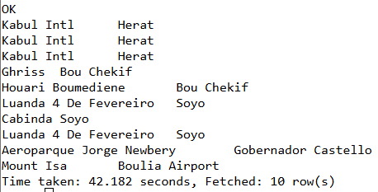
- Retrieve details of airlines that have more than 10 routes originating from Indian airports.
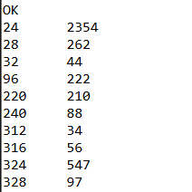
- Display the top 5 countries with the highest number of airports.
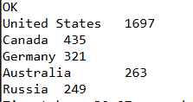

Part C: ORC and Parquet Storage Formats
- Create a copy of the routes table in ORC format.
- Create another copy of the routes table in Parquet format.
- Compare the storage size of the ORC and Parquet tables using HDFS commands.
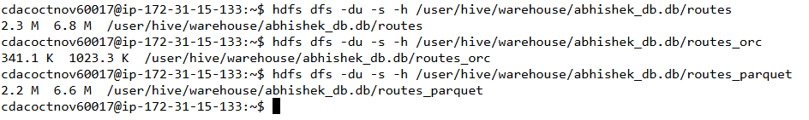The first Column represents the Actual size of the file, ie, 2.3 MB, and 6.8 MB is the file size after 3 replications.
The ORC has compressed the file to a size of 341.1 KB.
The Parquet has compressed the file to a size of 2.2 Mb.
- Run a simple count query on each table and compare performance.
  - Original table:
Stage-Stage-1: Map: 1 Reduce: 1 Cumulative CPU: 3.27 sec HDFS Read: 2389896 HDFS Write: 105 SUCCESS
Total MapReduce CPU Time Spent: 3 seconds 270 msec OK 66985 Time taken: 19.991 seconds, Fetched: 1 row(s)
  - ORC Table:
Stage-Stage-1: Map: 1 Reduce: 1 Cumulative CPU: 3.69 sec HDFS Read: 33413 HDFS Write: 105 SUCCESS
Total MapReduce CPU Time Spent: 3 seconds 690 msec
OK
66985
Time taken: 21.92 seconds, Fetched: 1 row(s)

  - Parquet Table:
Stage-Stage-1: Map: 1 Reduce: 1 Cumulative CPU: 3.44 sec HDFS Read: 2322309 HDFS Write: 105 SUCCESS
Total MapReduce CPU Time Spent: 3 seconds 440 msec
OK
66985
Time taken: 23.351 seconds, Fetched: 1 row(s)

- Explain the difference in how data is stored in TextFile, ORC, and Parquet formats.
This is the key concept. The way data is physically stored on disk dramatically impacts performance and size.
TextFile (Row-Based)
- How it works: This is the default. It stores data row by row, just like a plain CSV or text file.
- Analogy: A "To-Do List" on a piece of paper. To find all the deadlines, you must read every single line from top to bottom.
- Pros:
  - Simple and human-readable.
  - Universally supported.
- Cons
  - Very slow queries: To read one column, you must scan all columns.
  - Large file size: No compression by default.
ORC (Optimized Row Columnar)
- How it works: This is a columnar format. It stores data in blocks, with all values for a single column (e.g., all airline_ids) stored together.
- Analogy: A spreadsheet, but instead of one big file, you store each column in its own separate, highly compressed file.
- Pros:
    - Extremely fast queries: For SELECT COUNT (airline_id), it only reads the airline_id file and ignores all other data.
    - High compression: Takes up much less disk space.
    - Built-in indexes: Stores min/max/sum stats at the block level, allowing it to skip blocks of data it knows don't match a WHERE clause.

Parquet
- How it works: Also a columnar format, very similar to ORC. It was developed by Cloudera and Twitter and is the standard in the Spark ecosystem.
- Analogy: Same as the ORC spreadsheet analogy.
- Pros:
  - Extremely fast queries: (Same as ORC).
  - High compression: (Same as ORC).
  - Excellent with nested data: It is famously good at efficiently storing complex, nested data (like JSON structs or arrays), making it a favorite for Spark.

Part D: ACID and Transactional Tables
- Create a transactional table for airlines_txn that supports INSERT, UPDATE, and DELETE operations.

- Insert data from the existing airlines table into airlines_txn.
set hive.support.concurrency=true;
set hive.txn.manager=org.apache.hadoop.hive.ql.lockmgr.DbTxnManager;
set hive.enforce.bucketing=true;

- Update the active status of an airline to 'N' for a specific airline_id.
Update airline_txt set active=”N” where airline_id=1;
- Delete records of airlines that are inactive.
- Perform a major compaction on the transactional table and verify the results.

Part E: Hive Functions and UDFs
- Using built-in Hive functions, display the total number of airlines by country.
- Use a string function to extract the first three characters of the airport name for all airports.
- Use a conditional expression to classify airports based on altitude as 'High', 'Medium', or 'Low'.
- Create a Python-based UDF using the TRANSFORM clause to convert airline names to uppercase.
- Create another Python-based UDF to mask the first three letters of the airport name for privacy purposes.

Part F: Analytical and Scenario-Based Queries
- Find all airlines that operate direct flights (stops = 0) between two given airports.
- Retrieve the total number of routes per airline and order the result by the highest number of routes.
- Identify countries where no active airlines are currently operating.
- Display the number of airports per timezone.
- Using a join across all three tables, display the airline name, source airport, destination airport, and number of stops for flights operated by airlines based in India.

Part G: Conceptual and Descriptive Questions
- Explain the purpose of bucketing in Hive and its importance in ACID tables.
- Differentiate between managed and external tables in Hive with respect to data storage and deletion behavior.
- Describe the Map-Side and Reduce-Side join process in Hive.
- Explain how Hive determines whether to use a map-side join automatically.
Discuss the internal storage structure of ORC and Parquet files and how it helps improve query performance.

